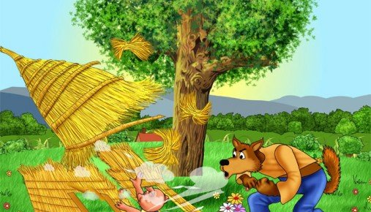

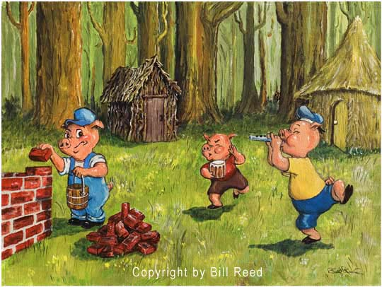

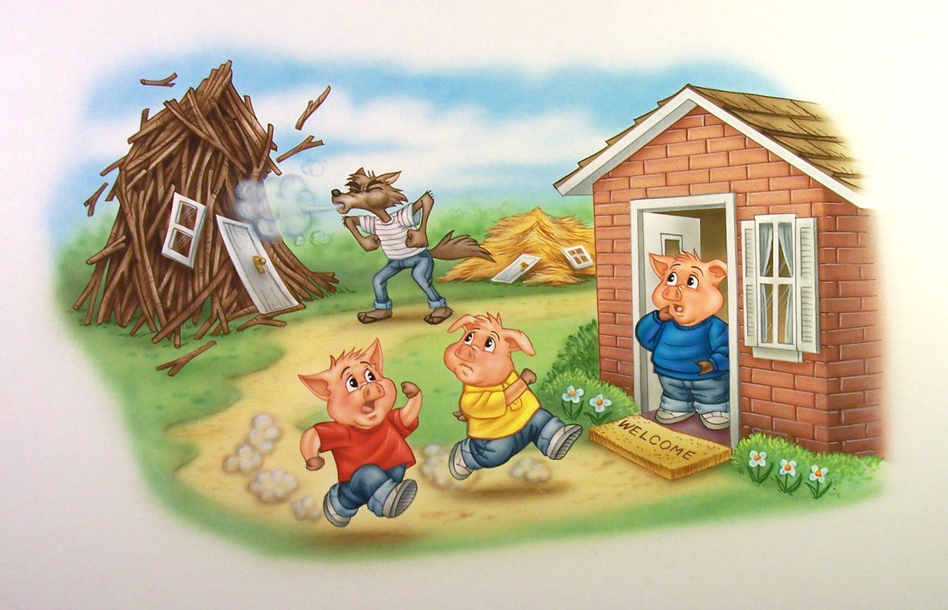

**Then the wolf blew down the second pig’s house. The pigs ran to the third pig’s house and were safe.**

**A wolf came and blew the first pig’s house down.**

**The three little pigs built houses to live in.**







**Then the wolf blew down the second pig’s house. The pigs ran to the third pig’s house and were safe.**

**A wolf came and blew the first pig’s house down.**

**The three little pigs built houses to live in.**







**Then the wolf blew down the second pig’s house. The pigs ran to the third pig’s house and were safe.**

**A wolf came and blew the first pig’s house down.**

**The three little pigs built houses to live in.**