[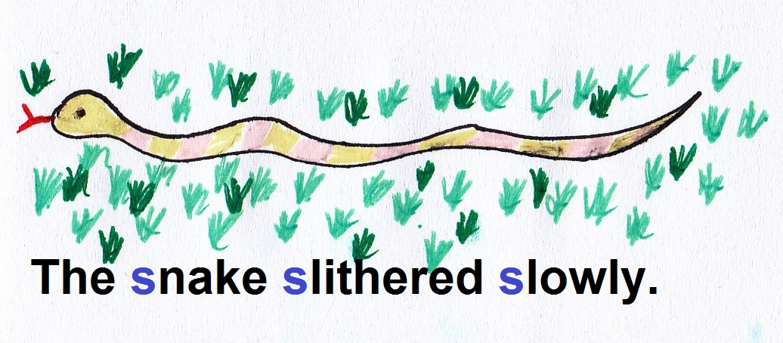](http://www.google.com/url?sa=i&rct=j&q=&esrc=s&source=images&cd=&cad=rja&uact=8&ved=0ahUKEwiNjZ-P-pnQAhXKQSYKHTm_BA4QjRwIBw&url=http%3A%2F%2Fsjbteaching.com%2Fa-is-also-foralliteration%2F&bvm=bv.138169073,d.amc&psig=AFQjCNGRsxWLAyKbjs7o7T_2EhcepEVsnw&ust=1478721618362698)

[](https://xiamenwriting.wikispaces.com/Alliteration)

[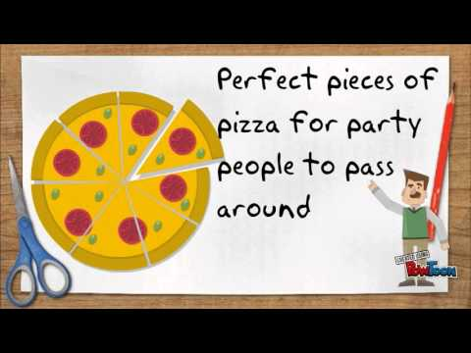](https://www.google.com/url?sa=i&rct=j&q=&esrc=s&source=images&cd=&cad=rja&uact=8&ved=0ahUKEwj8n4bm-pnQAhUBdyYKHU2BBpQQjRwIBw&url=https://www.youtube.com/watch?v%3DbcAHzYE4vjk&bvm=bv.138169073,d.amc&psig=AFQjCNGRsxWLAyKbjs7o7T_2EhcepEVsnw&ust=1478721618362698)

**Alliteration is when the same sound, letter, or group of sounds is repeated.**

**Alliteration**