Name: ________________________ Date: __________
Directions: Find the main topic and underline one detail that supports it.
Animals on the Farm
P1 Many animals live on farms. All of the animals help the farmer. The animals each have different jobs. The farmer needs all of the animals help to do his job.
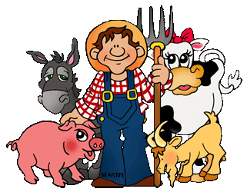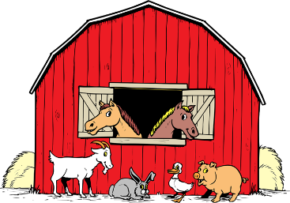
A barn with animals.
A farmer and his animals.

- Sub LEQ- What is the main topic of paragraph 1?
- The main topic is animals help the farmer.
- The main topic is animals are sleeping.
- The mains topic is the farmer has no animals.
- Why does the farmer have animals?
- To live in the barn.
- To be his friends.
- To help him do his job.
- List some animals that are on a farm.
_____________________________
_____________________________
_____________________________
_____________________________
_____________________________

P2 The farmer’s dog is an important helper on the farm. The dog helps the farmer herd other animals, like sheep. The dog herds the sheep by running next to the animals and showing them where to go. This helps the farmer get the sheep into the barn.
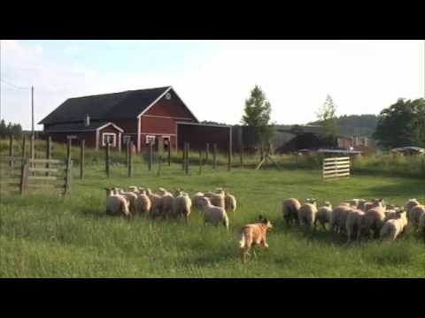
A dog herding sheep.
- Sub LEQ- What is the main topic of paragraph 2?
The main idea is ________________________________________________
_____________________________________________________________.
- How does the dog help the farmer?
- The dog helps the farmer dig.
- The dog helps the farmer herd animals.
- The dog does not help the farmer.

P3 Horses also help the farmer. The farmer can ride the horse around the farm. The horse can also pull tools the farmer needs. The horse is an important helper on the farm.
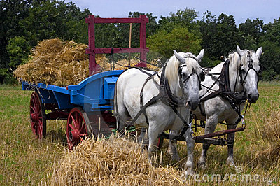
Horses pulling a cart for the farmer.

- Sub LEQ- What is the main topic of paragraph 3?
__________________________________________________________________________________________________________________________
- How does the horse help the farmer?
- The horse helps the farmer by pulling carts.
- The horse helps the farmer herd animals.
- The horse does not help the farmer.
- Who rides the horse on the farm?
- The dog.
- The pig.
- The farmer.

