[](http://www.google.com/url?sa=i&rct=j&q=&esrc=s&source=images&cd=&cad=rja&uact=8&ved=0ahUKEwjkl6TCsoXPAhVEeCYKHWlNC8EQjRwIBw&url=http%3A%2F%2Fworldartsme.com%2Fflower-growing-clipart.html&bvm=bv.132479545,d.eWE&psig=AFQjCNHDbzsA5mVhI6zb3QmIUoZy_cM0SQ&ust=1473617335401479)

[](https://www.google.com/url?sa=i&rct=j&q=&esrc=s&source=images&cd=&cad=rja&uact=8&ved=0ahUKEwjNwJ2Os4XPAhWEQCYKHSoeBrAQjRwIBw&url=https%3A%2F%2Fwww.tes.com%2Fteaching-resource%2Fdaily-events-sequencing-6374612&bvm=bv.132479545,d.eWE&psig=AFQjCNGvQz5-iAdl6hR7YcINe7EA97xUWQ&ust=1473617485612961)

[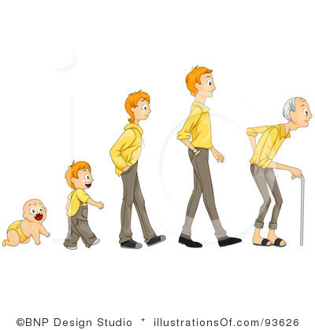](http://www.google.com/url?sa=i&rct=j&q=&esrc=s&source=images&cd=&cad=rja&uact=8&ved=0ahUKEwjhrrncsoXPAhVLOSYKHfmPArAQjRwIBw&url=http%3A%2F%2Fsc2218.wikifoundry.com%2Fpage%2FA%2BLook%2BInto%2BGender&bvm=bv.132479545,d.eWE&psig=AFQjCNGujj6-d926Pd2AE62y_N31vJZw9Q&ust=1473617367755804)

[](http://www.google.com/url?sa=i&rct=j&q=&esrc=s&source=images&cd=&cad=rja&uact=8&ved=0ahUKEwiNt7Chs4XPAhWFLyYKHQ5pAAEQjRwIBw&url=http%3A%2F%2Fwww.dailymail.co.uk%2Fnews%2Farticle-2232618%2FOn-64th-birthday-Prince-Charles-dispels-myths-him.html&bvm=bv.132479545,d.eWE&psig=AFQjCNE4egyBq-y6fw5EHrx_66bCsWv9ZQ&ust=1473617529478075) [](http://www.google.com/url?sa=i&rct=j&q=&esrc=s&source=images&cd=&cad=rja&uact=8&ved=0ahUKEwjvvsi_s4XPAhXD6yYKHc6hD0YQjRwIBw&url=http%3A%2F%2Fwww.huffingtonpost.com%2F2015%2F04%2F24%2Fforgot-to-brush-teeth-gross_n_5800102.html&bvm=bv.132479545,d.eWE&psig=AFQjCNHB3moV8WHE9SEHm2A9R6BwtwcWdQ&ust=1473617569058654) [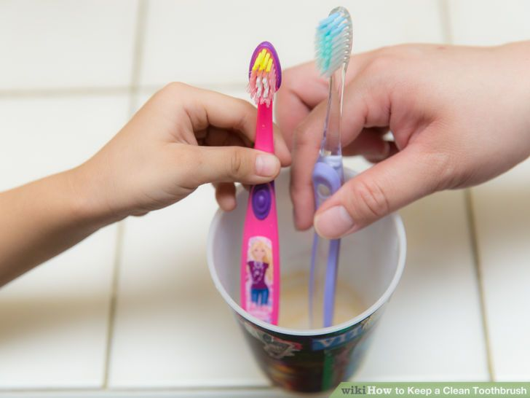](http://www.google.com/url?sa=i&rct=j&q=&esrc=s&source=images&cd=&cad=rja&uact=8&ved=0ahUKEwiasY7Ts4XPAhVCNiYKHYHmBoUQjRwIBw&url=http%3A%2F%2Fwww.wikihow.com%2FKeep-a-Clean-Toothbrush&bvm=bv.132479545,d.eWE&psig=AFQjCNH0PYs-vocvz8QJTvVKW1Ydv0p6PQ&ust=1473617624001622) [](http://www.google.com/url?sa=i&rct=j&q=&esrc=s&source=images&cd=&cad=rja&uact=8&ved=0ahUKEwiNqbX5s4XPAhVEKCYKHTytCMcQjRwIBw&url=http%3A%2F%2Fwww.cleveland.com%2Ftaste%2Findex.ssf%2F2010%2F06%2Fcake_mix_bar_cookies_are_perfe.html&bvm=bv.132479545,d.eWE&psig=AFQjCNEE6kD23h9jG8fxn9m2wxXhHKPzMA&ust=1473617721942252)

[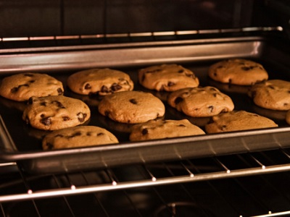](http://www.google.com/url?sa=i&rct=j&q=&esrc=s&source=images&cd=&cad=rja&uact=8&ved=0ahUKEwiajOyItIXPAhVIYyYKHX_jBa8QjRwIBw&url=http%3A%2F%2Fwww.hellawella.com%2Fbake-ultimate-chocolate-chip-cookie-and-figure-out-what-you%25E2%2580%2599ve-been-doing-wrong&bvm=bv.132479545,d.eWE&psig=AFQjCNFra27IBlDdadmlqtG2z_9hPTs0fQ&ust=1473617745027791) [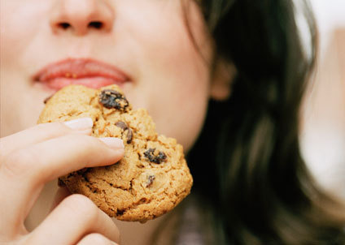](http://www.google.com/url?sa=i&rct=j&q=&esrc=s&source=images&cd=&cad=rja&uact=8&ved=0ahUKEwjLpoadtIXPAhUCOyYKHSzCDtMQjRwIBw&url=http%3A%2F%2Fsteamcommunity.com%2Fsharedfiles%2Ffiledetails%2F%3Fid%3D490264036&bvm=bv.132479545,d.eWE&psig=AFQjCNFPm8wVHU6h-e11snGhum0HaKm0sA&ust=1473617771701609)

[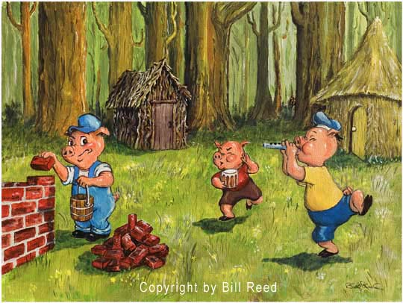](http://www.google.com/url?sa=i&rct=j&q=&esrc=s&source=images&cd=&cad=rja&uact=8&ved=0ahUKEwiO4fe_tIXPAhUKMSYKHTWYC1QQjRwIBw&url=http%3A%2F%2Fyvonneling93.blogspot.com%2F2013%2F07%2Fthe-story-of-three-little-pigs.html&bvm=bv.132479545,d.eWE&psig=AFQjCNEUVyix_3QXfLfz85WQsJXfdYsZIQ&ust=1473617866571498) [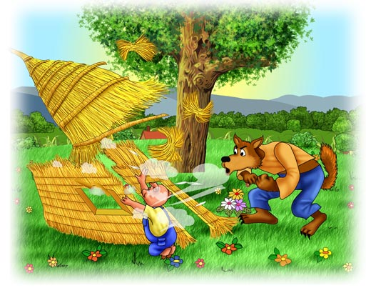](http://www.google.com/url?sa=i&rct=j&q=&esrc=s&source=images&cd=&cad=rja&uact=8&ved=0ahUKEwjdlrjTtIXPAhWDMyYKHdQKBl0QjRwIBw&url=http%3A%2F%2Fwww.thinglink.com%2Fscene%2F626936494799454209&bvm=bv.132479545,d.eWE&psig=AFQjCNG7jXjW_-5ZO5ro-s1vosebIkUhXw&ust=1473617909968252)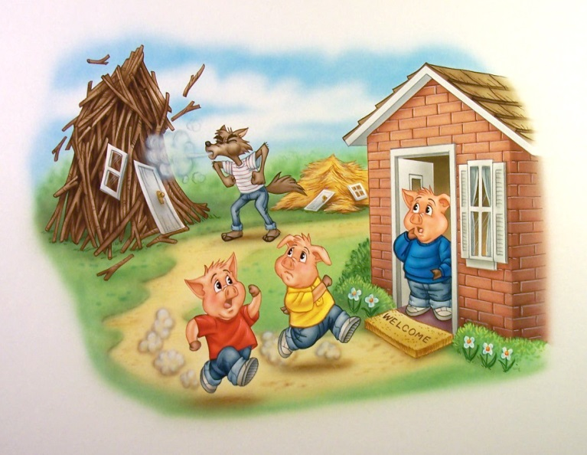[](http://www.google.com/url?sa=i&rct=j&q=&esrc=s&source=images&cd=&cad=rja&uact=8&ved=0ahUKEwiTvoqotYXPAhWK5yYKHZTzALMQjRwIBw&url=http%3A%2F%2Fgoogoogallerykids.blogspot.com%2F2011%2F02%2Fobscure-scan-sunday-three-bears.html&bvm=bv.132479545,d.eWE&psig=AFQjCNG2etggYxa36iYJ1XBGKV2H3MHg4A&ust=1473618083148504) [](https://www.google.com/url?sa=i&rct=j&q=&esrc=s&source=images&cd=&cad=rja&uact=8&ved=0ahUKEwj-6ZyvtYXPAhUG6iYKHSuaAsQQjRwIBw&url=https%3A%2F%2Fwww.pinterest.com%2Fpin%2F428404983276267641%2F&bvm=bv.132479545,d.eWE&psig=AFQjCNG2etggYxa36iYJ1XBGKV2H3MHg4A&ust=1473618083148504) [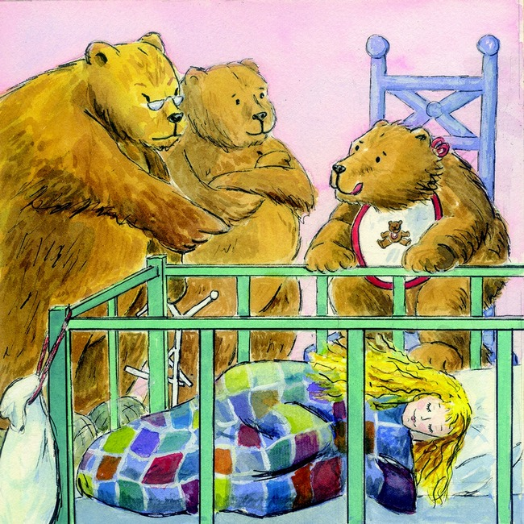](https://www.google.com/url?sa=i&rct=j&q=&esrc=s&source=images&cd=&cad=rja&uact=8&ved=0ahUKEwj-6ZyvtYXPAhUG6iYKHSuaAsQQjRwIBw&url=https%3A%2F%2Fjoehentges.net%2Fgoldilocks%2F&bvm=bv.132479545,d.eWE&psig=AFQjCNG2etggYxa36iYJ1XBGKV2H3MHg4A&ust=1473618083148504)