Name: ________________________________ Date: ____________
Print Concepts: Circle one letter.

The leaf.

Circle the letter c in red. Circle the letter o in green. Circle the letter a in blue.
a o c

Sub LEQ: How do I use words and pictures to identify the main topic?
I find the main topic by ____________.
Listen to the words and look for key details. | Look for key details.

Sub LEQ: How do I identify the main topic?
The main topic of our book is _______________.
corn | fall

I find the main topic by ______________.
Looking at the title. | See what the book is mostly about.

Sub LEQ: How do identify a key detail?
The main topic is letters. What is one key detail?
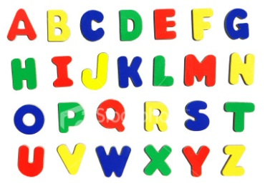
I identify a key detail by ____________.
Looking at the title. | Finding what tells me more about the topic.

LEQ: How do I identify the main topic and retell key details of a text?
I find the main topic and retell by _______________________
Using key details to talk about the text. | Looking at the title.

Print Concepts: Circle two letters.

The chair.

