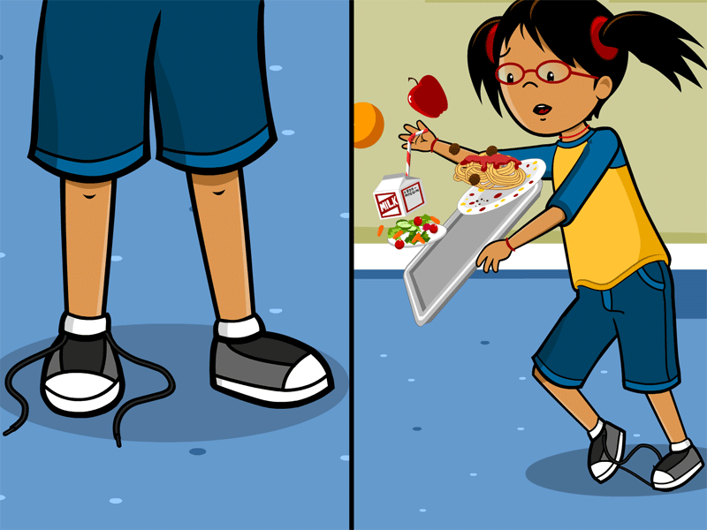

**Cause Effect**

**A cause is why something happens. An effect is what happens. These show how one event causes another event.**

**Cause and effect**