**A challenge is the problem the character or characters face.**

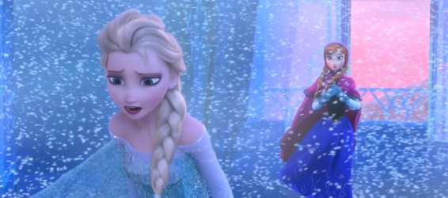

**Elsa’s challenge is her ice power.**

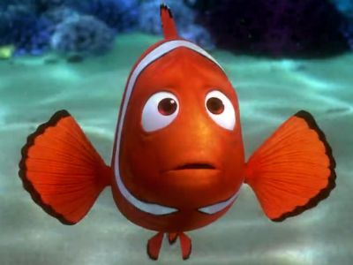

**Marlin’s challenge is to find his son, Nemo.**

**Challenge**

**Dogs are animals.**