

[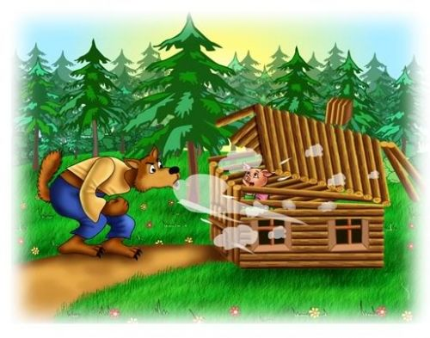](https://www.google.com/url?sa=i&rct=j&q=&esrc=s&source=images&cd=&cad=rja&uact=8&ved=0ahUKEwi6tabGqIXPAhWLdSYKHfKtCRIQjRwIBw&url=https%3A%2F%2Fwww.pinterest.com%2Fpin%2F516647388474557609%2F&bvm=bv.132479545,d.eWE&psig=AFQjCNEomHn_jzlG7FmwQs6gdDtbu138Cw&ust=1473614661795681)[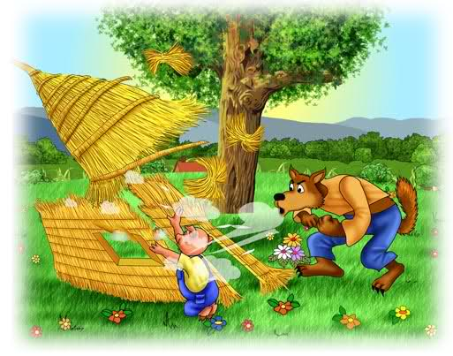](http://emanstantberg.weebly.com/archetypesthemesmotifs.html)

[](http://www.google.com/url?sa=i&rct=j&q=&esrc=s&source=images&cd=&cad=rja&uact=8&ved=0ahUKEwjY_proqIXPAhVIxCYKHXLVAwIQjRwIBw&url=http%3A%2F%2Fwww.cosmickids.com%2Fclassplans%2Fgoldilocks-three-bears-kids-yoga-class-plan%2F&bvm=bv.132479545,d.eWE&psig=AFQjCNGEKOzamL4bZyDs3TnNGZuMWuFKNQ&ust=1473614726395319)[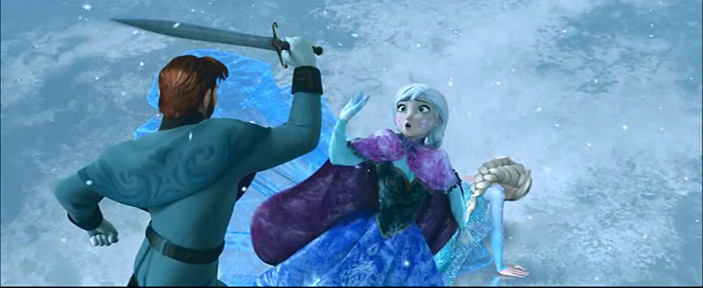](http://www.google.com/url?sa=i&rct=j&q=&esrc=s&source=images&cd=&cad=rja&uact=8&ved=0ahUKEwiTj9-AqYXPAhUDbiYKHYGtB5IQjRwIBw&url=http%3A%2F%2Ftvtropes.org%2Fpmwiki%2Fposts.php%3Fdiscussion%3D1426004395078450100%26page%3D2&bvm=bv.132479545,d.eWE&psig=AFQjCNHeB8fiZ0XSo68u26Q0l6OlsOLeCQ&ust=1473614756377386)

[](http://www.google.com/url?sa=i&rct=j&q=&esrc=s&source=images&cd=&cad=rja&uact=8&ved=0ahUKEwjHxKqSqYXPAhXHwiYKHaFuDNUQjRwIBw&url=http%3A%2F%2Fwww.aceshowbiz.com%2Fnews%2Fview%2F00061820.html&bvm=bv.132479545,d.eWE&psig=AFQjCNEafo8a2-pjakMmPB_HQBE9I6XeIQ&ust=1473614816924318)[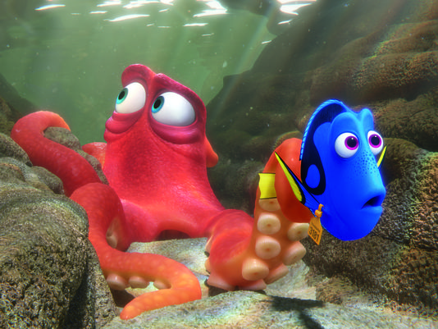](http://www.google.com/url?sa=i&rct=j&q=&esrc=s&source=images&cd=&cad=rja&uact=8&ved=0ahUKEwiJlZjHqYXPAhVL4iYKHbwBDHIQjRwIBw&url=http%3A%2F%2Fwww.azcentral.com%2Fstory%2Fentertainment%2Fmovies%2Fbillgoodykoontz%2F2016%2F06%2F15%2Ffinding-dory-movie-review-pixar-disney%2F85876896%2F&bvm=bv.132479545,d.eWE&psig=AFQjCNFjq3YxNNQNjfFXZ9vPCz5Alfr2Iw&ust=1473614918762904)[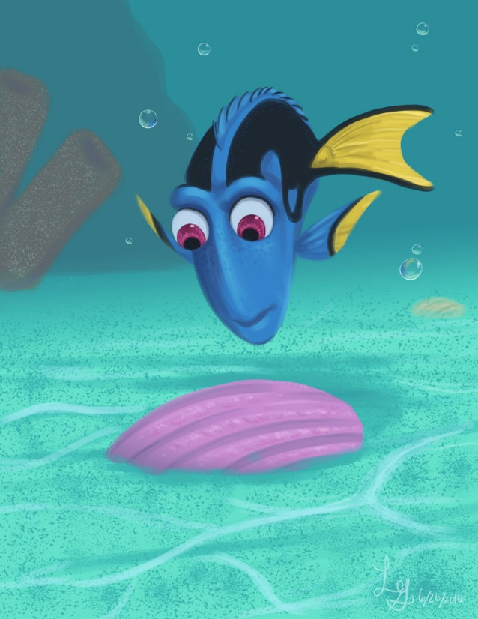](http://www.google.com/url?sa=i&rct=j&q=&esrc=s&source=images&cd=&cad=rja&uact=8&ved=0ahUKEwjYgNjZqYXPAhUK6yYKHfwFD4gQjRwIBw&url=http%3A%2F%2Fwww.deviantart.com%2Fbrowse%2Fall%2F%3Foffset%3D22%26view_mode%3D2%26order%3D15%26q%3Dfinding%2Bdory&bvm=bv.132479545,d.eWE&psig=AFQjCNGLfw2B0jiMLTOk1XcPBVEPEzH8-g&ust=1473614964037474)[](http://www.google.com/url?sa=i&rct=j&q=&esrc=s&source=images&cd=&ved=0ahUKEwi0wY7iqYXPAhUDSyYKHY_QDEcQjRwIBw&url=http%3A%2F%2Fcartoonbros.com%2Fspongebob-squarepants%2F&bvm=bv.132479545,d.eWE&psig=AFQjCNHaCrHqGxb3x8sz8bxFpuv3QR_zOg&ust=1473614988336607)[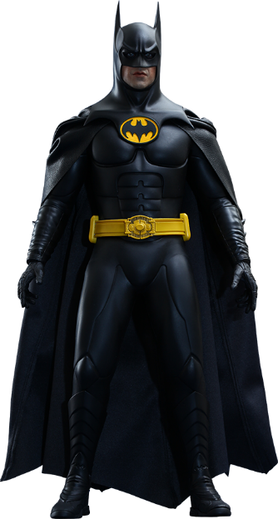](http://www.google.com/url?sa=i&rct=j&q=&esrc=s&source=images&cd=&cad=rja&uact=8&ved=0ahUKEwi-_qHuqYXPAhVDOCYKHa_UB-MQjRwIBw&url=http%3A%2F%2Fwww.sideshowtoy.com%2Fcollectibles%2Fdc-comics-batman-hot-toys-902399%2F&bvm=bv.132479545,d.eWE&psig=AFQjCNHf0OCD252Q7Jp5k22ZW6MoEz_MLg&ust=1473615011824349)[](https://www.google.com/url?sa=i&rct=j&q=&esrc=s&source=images&cd=&cad=rja&uact=8&ved=0ahUKEwjcsaL-qYXPAhUC7yYKHbfkD7kQjRwIBw&url=https%3A%2F%2Fmarvelheroes.com%2Fheroes%2Fhulk&bvm=bv.132479545,d.eWE&psig=AFQjCNEsRYxDarMj4CzpnFNk5Ktuxc_JHg&ust=1473615031603633)[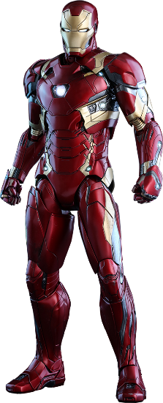](http://www.google.com/url?sa=i&rct=j&q=&esrc=s&source=images&cd=&cad=rja&uact=8&ved=0ahUKEwjeztCNqoXPAhXJYyYKHcoUBOQQjRwIBw&url=http%3A%2F%2Fwww.sideshowtoy.com%2Fcollectibles%2Fmarvel-iron-man-mark-xlvi-hot-toys-902708%2F&bvm=bv.132479545,d.eWE&psig=AFQjCNH1_3hdJvsvEIlwaaYVlRNMLzgvVA&ust=1473615064781514)[](http://www.google.com/url?sa=i&rct=j&q=&esrc=s&source=images&cd=&cad=rja&uact=8&ved=0ahUKEwjH0-CXqoXPAhXH5yYKHU8LBPIQjRwIBw&url=http%3A%2F%2Fwww.thefeministwire.com%2F2014%2F03%2Fprincess-culture%2F&bvm=bv.132479545,d.eWE&psig=AFQjCNHJCa51X5qd8AEnM2vOLeRDn4L0vQ&ust=1473615101217924)[](https://www.google.com/url?sa=i&rct=j&q=&esrc=s&source=images&cd=&cad=rja&uact=8&ved=0ahUKEwin7MijqoXPAhXKNiYKHSVcDNMQjRwIBw&url=https%3A%2F%2Fwww.pinterest.com%2Fkihaku%2Fcosplay-disney-tiana%2F&bvm=bv.132479545,d.eWE&psig=AFQjCNH9bTyOn3XKkaQpVB6-01t9a3tatg&ust=1473615126220715)[](http://www.google.com/url?sa=i&rct=j&q=&esrc=s&source=images&cd=&cad=rja&uact=8&ved=0ahUKEwiT85iwqoXPAhVG6yYKHW4kDjYQjRwIBw&url=http%3A%2F%2Fwww.tvguide.com%2Fmovies%2Fmulan%2F133051%2F&bvm=bv.132479545,d.eWE&psig=AFQjCNEE0R_eehm2gbIneigPY1eCvPBiSA&ust=1473615141580531)[](http://www.google.com/url?sa=i&rct=j&q=&esrc=s&source=images&cd=&cad=rja&uact=8&ved=0ahUKEwjd-9LGqoXPAhWJ7yYKHdiTAHMQjRwIBw&url=http%3A%2F%2Fwww.10best.com%2Fdestinations%2Fflorida%2Ffort-myers%2Fattractions%2Fbeaches%2F&bvm=bv.132479545,d.eWE&psig=AFQjCNEDbGJhGt2lFmDsCRsrceaKJdG8Wg&ust=1473615176759363)[](http://www.google.com/url?sa=i&rct=j&q=&esrc=s&source=images&cd=&cad=rja&uact=8&ved=0ahUKEwi0_OTZqoXPAhUENSYKHYNJBCUQjRwIBw&url=http%3A%2F%2Fclipartix.com%2Fcastle-clip-art%2F&bvm=bv.132479545,d.eWE&psig=AFQjCNEd6IhEd0NPrQgdsF_6I_CHQDBYKg&ust=1473615219848703)[](http://www.google.com/url?sa=i&rct=j&q=&esrc=s&source=images&cd=&cad=rja&uact=8&ved=0ahUKEwiV08flqoXPAhUGMSYKHdZVDq0QjRwIBw&url=http%3A%2F%2Fclassroomclipart.com%2Fclipart%2FClipart%2FHome.htm&bvm=bv.132479545,d.eWE&psig=AFQjCNFgPF0ZBy5d7sXyO53HM8N7Lo473g&ust=1473615263714051)[](http://www.google.com/url?sa=i&rct=j&q=&esrc=s&source=images&cd=&cad=rja&uact=8&ved=0ahUKEwiX5tb1qoXPAhVTfiYKHeoYCcUQjRwIBw&url=http%3A%2F%2Fwww.shutterstock.com%2Fpic-81047143%2Fstock-vector-time-to-go-back-school-vector-illustration-background-bus-children-and-school-facade-composition.html&bvm=bv.132479545,d.eWE&psig=AFQjCNHeEIILoHfax2B8L9hUjZGafB9QCA&ust=1473615284133757)[](http://www.google.com/url?sa=i&rct=j&q=&esrc=s&source=images&cd=&cad=rja&uact=8&ved=0ahUKEwj8tdWEq4XPAhUC4iYKHX3jAO8QjRwIBw&url=http%3A%2F%2Fwww.clipartkid.com%2Fart-school-cliparts%2F&bvm=bv.132479545,d.eWE&psig=AFQjCNGe3JkcQcQhGMyvJ_0EqB_i9QRYUg&ust=1473615315019146)[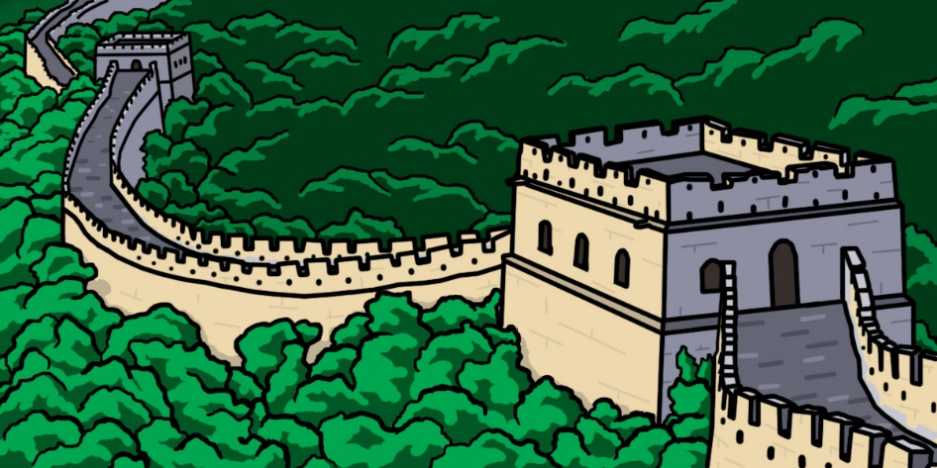](http://www.google.com/url?sa=i&rct=j&q=&esrc=s&source=images&cd=&cad=rja&uact=8&ved=0ahUKEwiyweeTq4XPAhUGZCYKHSvDCjsQjRwIBw&url=http%3A%2F%2Fwww.clipartkid.com%2Fgreat-wall-of-china-cliparts%2F&bvm=bv.132479545,d.eWE&psig=AFQjCNGXWtiyc3ksDsCXd1niXaZhRzIKmw&ust=1473615358302193)[](http://www.google.com/url?sa=i&rct=j&q=&esrc=s&source=images&cd=&cad=rja&uact=8&ved=0ahUKEwjN1Lihq4XPAhXFNiYKHSc5DIQQjRwIBw&url=http%3A%2F%2Fclipartix.com%2Feiffel-tower-clip-art-image-2578%2F&bvm=bv.132479545,d.eWE&psig=AFQjCNETUSQ9D8elucoGJ4mZ5k2DHNmwuA&ust=1473615380884290)

[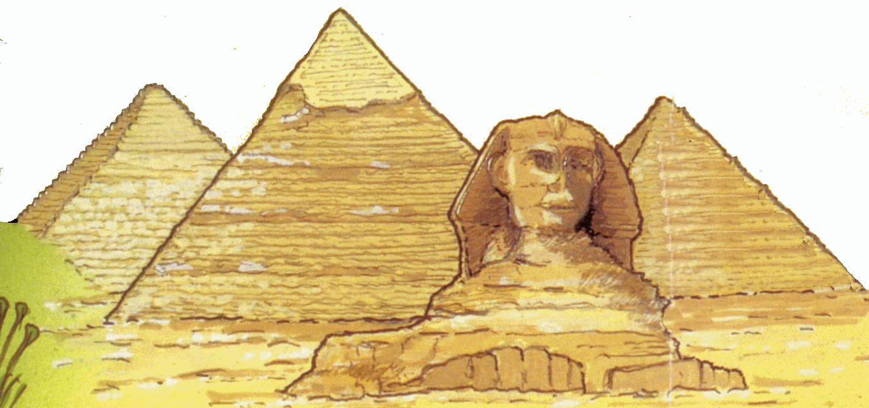](http://www.google.com/url?sa=i&rct=j&q=&esrc=s&source=images&cd=&cad=rja&uact=8&ved=0ahUKEwimi7qwq4XPAhWGLSYKHbRSBVAQjRwIBw&url=http%3A%2F%2Fwww.clipartkid.com%2Fegypt-pyramid-cliparts%2F&bvm=bv.132479545,d.eWE&psig=AFQjCNFjXAYeBDHT7gQT6np1I4qXxbcZrQ&ust=1473615418282329)[](http://www.google.com/url?sa=i&rct=j&q=&esrc=s&source=images&cd=&cad=rja&uact=8&ved=0ahUKEwj_6O_Eq4XPAhVGKyYKHW1-DMAQjRwIBw&url=http%3A%2F%2Fwww.thomasandfriends.com%2Fen-us%2Fkids%2Fengines&bvm=bv.132479545,d.eWE&psig=AFQjCNHLr7FauOJN0caK6grcBGUh8_5BEQ&ust=1473615442063837)

[](https://www.google.com/url?sa=i&rct=j&q=&esrc=s&source=images&cd=&cad=rja&uact=8&ved=0ahUKEwjAxOfQq4XPAhVEeSYKHf7AANoQjRwIBw&url=https%3A%2F%2Fen.wikipedia.org%2Fwiki%2FMickey_Mouse&bvm=bv.132479545,d.eWE&psig=AFQjCNEXEeVjBkOo1J5x9Igt-ADETWQbVg&ust=1473615486161125)[](https://www.google.com/url?sa=i&rct=j&q=&esrc=s&source=images&cd=&cad=rja&uact=8&ved=0ahUKEwiai8Pgq4XPAhVGbiYKHRB1C-YQjRwIBw&url=https%3A%2F%2Fen.wikipedia.org%2Fwiki%2FMater_(Cars)&bvm=bv.132479545,d.eWE&psig=AFQjCNEacHCa3jm3JN7XPGvzBf_JKwvmzA&ust=1473615517208403)