**Compare**

* Both are fruits.
* Both have juice.
* Both grow on trees.

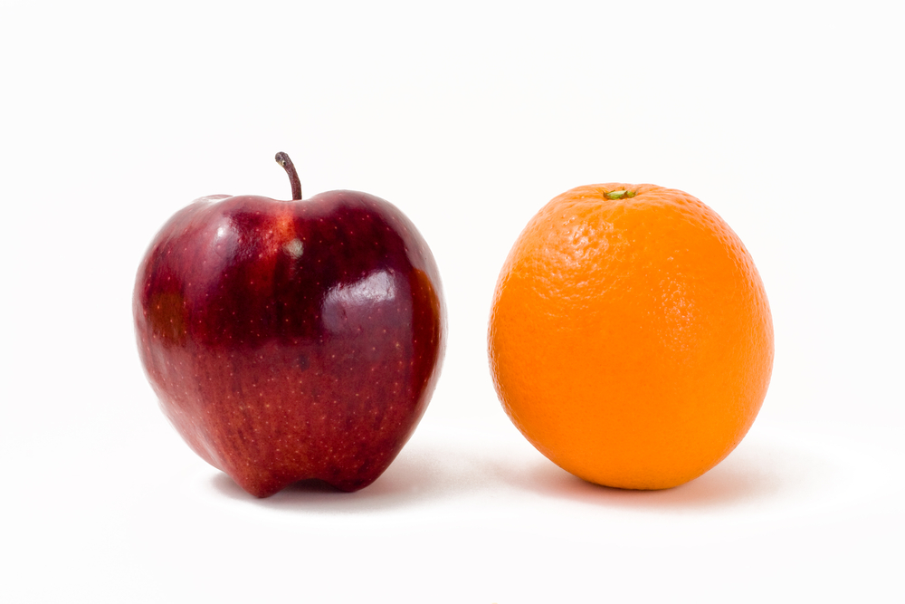

**Contrast**

* One apple is red and one is orange.
* The orange has a thick skin and the apple has a thin skin.

**When you contrast you look at how things are different or unlike.**

**When you compare you look at how things are the same or similar.**

**Compare and contrast**