**Text**

[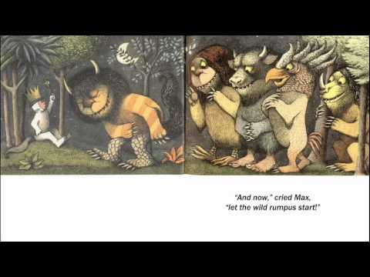](https://www.google.com/url?sa=i&rct=j&q=&esrc=s&source=images&cd=&cad=rja&uact=8&ved=0ahUKEwjyx_mOlYXPAhWFWSYKHVM5DdMQjRwIBw&url=https%3A%2F%2Fwww.youtube.com%2Fwatch%3Fv%3D2bptuYPvfgk&bvm=bv.132479545,d.eWE&psig=AFQjCNGgkJTCs9k7ONVP54ge_xie4dFHrA&ust=1473609398578118)

**Text Features**

[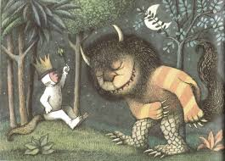](http://www.google.com/url?sa=i&rct=j&q=&esrc=s&source=images&cd=&cad=rja&uact=8&ved=0ahUKEwiQy-m5lIXPAhVJbSYKHY2PB2UQjRwIBw&url=http%3A%2F%2Fziot.dvrlists.com%2Fbook-illustrations%2F&bvm=bv.132479545,d.eWE&psig=AFQjCNHpvnEVx6NTFuXALYEFmLBN8sX3bA&ust=1473609234962179)

**The details are little parts that help you understand the text. You can find details in the text features and in the text.**

**details**