Name: __________________________________ Date: _____________
Problem Solution

________________________________
________________________________
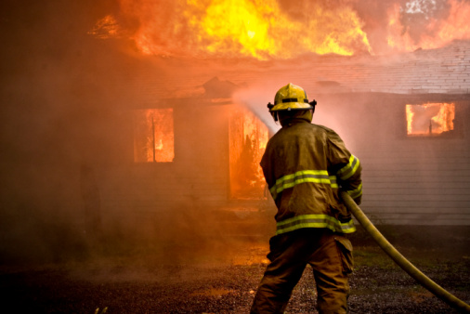
Firefighters came to help.___________

RI 2.3

Name: __________________________________ Date: _____________
Problem Solution

________________________________
________________________________
Firefighters came to help.___________

RI 2.3

