Name: _____________________ Date: ________
A Red Car
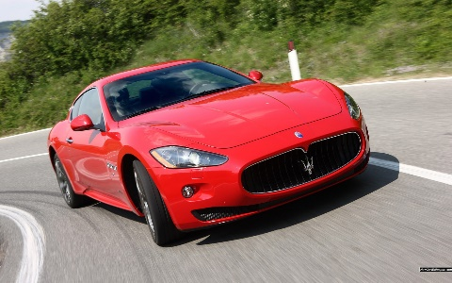
I see a red car. I can go home in the red car. I can go to school in the red car. The red car is fast. My mom and I are in the red car.
- What color is the car? ___________________________________
- Is the car fast or slow? ___________________________________
- Who is in the car? _______________________________________
Family
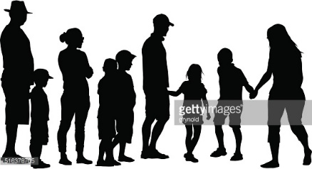
I have a big family. I have a mom and dad. I have 3 sisters and 4 brothers. I have a dog and a cat. I love my family.
- How many sisters are in the family? ____________________________
- How many brothers are in the family? __________________________
- What animals are in the family? _______________________________

Sub LEQ: How do I find the answers to questions?
- Look in the text.
- Look at the picture.
- Look at the title.

Horse
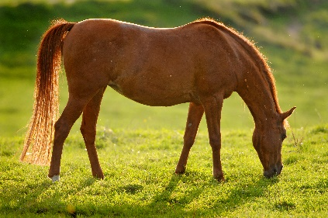
I have a horse. My horse is big and brown. I can ride on my horse. I call my horse Max. He eats hay and apples.
- What color is the horse? _________________________________
- What is the name of the horse? ____________________________
- What does the horse eat? ________________________________

