[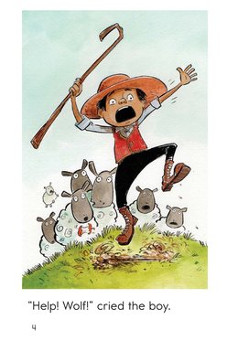](https://www.google.com/url?sa=i&rct=j&q=&esrc=s&source=images&cd=&cad=rja&uact=8&ved=0ahUKEwi4_6bE7fXOAhVDOCYKHWF0B3wQjRwIBw&url=https://www.readinga-z.com/book.php?id%3D1978&psig=AFQjCNE435KqzRThMH4UFd6H9N5QvsbPtQ&ust=1473083338063807)[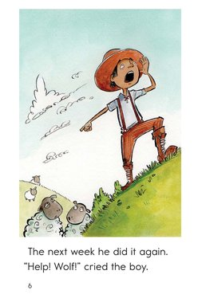](https://www.google.com/url?sa=i&rct=j&q=&esrc=s&source=images&cd=&cad=rja&uact=8&ved=0ahUKEwiAxcHj7fXOAhUDOyYKHe2IDjQQjRwIBw&url=https://www.readinga-z.com/book.php?id%3D1978&psig=AFQjCNE435KqzRThMH4UFd6H9N5QvsbPtQ&ust=1473083338063807)[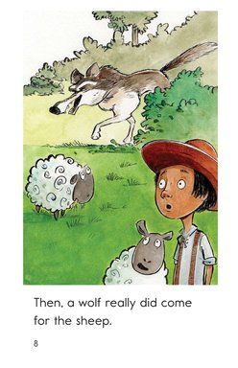](https://www.google.com/url?sa=i&rct=j&q=&esrc=s&source=images&cd=&cad=rja&uact=8&ved=0ahUKEwiNop387fXOAhXBQyYKHQbeDHIQjRwIBw&url=https://www.readinga-z.com/book.php?id%3D1978&psig=AFQjCNE435KqzRThMH4UFd6H9N5QvsbPtQ&ust=1473083338063807)