**I need…**

**the bathroom the water fountain**

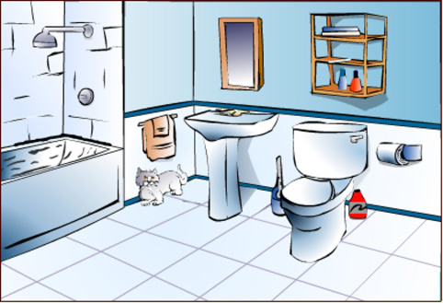 [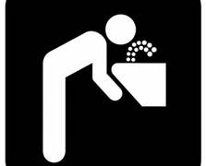](http://www.bing.com/images/search?q=water+fountain+clipart&qs=n&form=QBIR&pq=water+fountain+clipart&sc=6-20&sp=-1&sk=&adlt=strict#view=detail&id=6694275C51C452B08A0F599C6671C4DF2451ECAE&selectedIndex=6)

**a pencil**

[](http://www.bing.com/images/search?q=pencilclipart&qs=n&form=QBIR&pq=pencilclipart&sc=8-8&sp=-1&sk=&adlt=strict#view=detail&id=13F909502CC2FDF4E7A0967CC8AD5A06AB0FACE1&selectedIndex=1)

**help a tissue**

[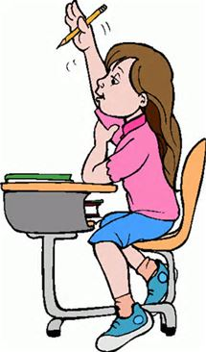](http://www.bing.com/images/search?q=raise+hand+Clip+Art&qs=n&form=QBIR&pq=raise+hand+clip+art&sc=1-18&sp=-1&sk=&adlt=strict#view=detail&id=CCD761C3D4D9EEA754C0669BA133857C4ACEB263&selectedIndex=0) 