Name: _______________________________
On
1. What is the monkey on last?
The monkey is ______________________________________________________.

Name: _______________________________
On
1. What is the monkey on last?
The monkey is ______________________________________________________.

2. Who is a character in the book?
The character is ____________________________________________________.
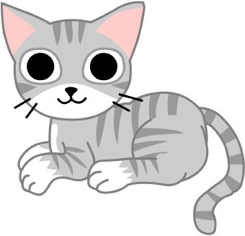  the cat | 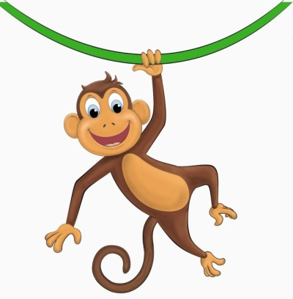  the monkey | 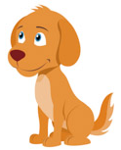  the dog

2. Who is a character in the book?
The character is ____________________________________________________.
the cat | the monkey | the dog

3. Where is the monkey on page 6?
The monkey is ____________________________________________________.

3. Where is the monkey on page 6?
The monkey is ____________________________________________________.
4. Why is the monkey on the table?
The monkey wants __________________________________________________.
an apple | 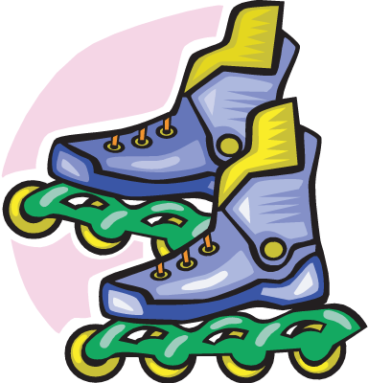  the skates | 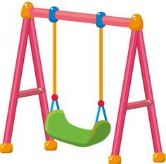  to swing

4. Why is the monkey on the table?
The monkey wants __________________________________________________.
an apple | the skates | to swing

