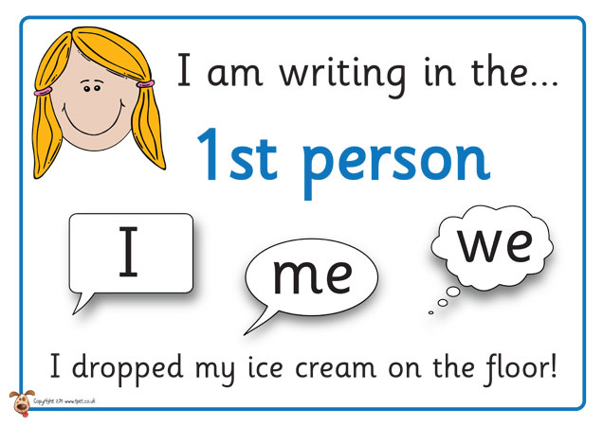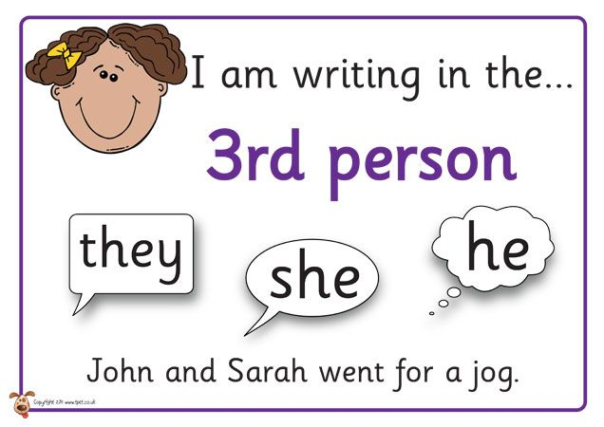

**First Person**

* **The character tells the story.**
* **I, we, me, my, our, mine**

**Third Person**

* **The story is told by a narrator who is not in the story.**
* **She, he, they, them, their, his her, names**

**Point of view**

**Look at what a character says and does. Also, think about how that character feels.**

**Dogs are animals.**