[](http://www.google.com/url?sa=i&rct=j&q=&esrc=s&source=images&cd=&cad=rja&uact=8&ved=0ahUKEwjUzu3-vIXPAhWE6CYKHcnnBk8QjRwIBw&url=http://www.dragonmount.com/forums/topic/87822-random-image-association-game/page-4&psig=AFQjCNFDwCFpCnIAzi6udTlFCtfsGuk2Hg&ust=1473620142530667)[](http://www.google.com/url?sa=i&rct=j&q=&esrc=s&source=images&cd=&cad=rja&uact=8&ved=0ahUKEwjb08WLvYXPAhVBKCYKHQc4C_QQjRwIBw&url=http://www.clipartkid.com/take-a-bath-cliparts/&bvm=bv.132479545,d.cWw&psig=AFQjCNGYAjrLj3UsDvpCn_8gdL32vWfT-w&ust=1473620176522284)

[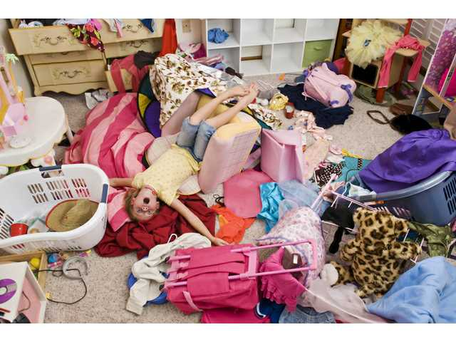](http://www.google.com/url?sa=i&rct=j&q=&esrc=s&source=images&cd=&cad=rja&uact=8&ved=0ahUKEwjKrNmkvYXPAhXC6iYKHS0RAzEQjRwIBw&url=http://www.chronicle-independent.com/archives/33722/&bvm=bv.132479545,d.cWw&psig=AFQjCNGFrxbnV8NKGqegX-GbllP2dL1AWw&ust=1473620200521482)[](http://www.google.com/url?sa=i&rct=j&q=&esrc=s&source=images&cd=&cad=rja&uact=8&ved=0ahUKEwiusc7RvYXPAhWB2SYKHT9wDRUQjRwIBw&url=http://www.clipartkid.com/tidy-room-cliparts/&bvm=bv.132479545,d.cWw&psig=AFQjCNGtB71QuYuzMokw1vAs0uABGlzJDw&ust=1473620300201799)[](http://www.google.com/url?sa=i&rct=j&q=&esrc=s&source=images&cd=&cad=rja&uact=8&ved=0ahUKEwjEkOiAvoXPAhWIKCYKHcuWDJcQjRwIBw&url=http://www.clipartkid.com/hurt-cat-cliparts/&bvm=bv.132479545,d.cWw&psig=AFQjCNHrhCYStD6G1nsN0731YcuSkGzoXw&ust=1473620422736857)[](http://berryripe.com/band-aid/)[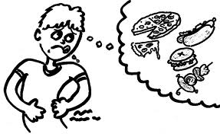](http://www.google.com/url?sa=i&rct=j&q=&esrc=s&source=images&cd=&cad=rja&uact=8&ved=0ahUKEwjl8tmcvoXPAhUBcSYKHfFbA-0QjRwIBw&url=http://www.hmrdiet.com/succeed/Blog/P/317&bvm=bv.132479545,d.cWw&psig=AFQjCNF3zDYOTD_6cKkQendaaaJJy37E-A&ust=1473620472018624)[](http://www.google.com/url?sa=i&rct=j&q=&esrc=s&source=images&cd=&ved=0ahUKEwjQiKitvoXPAhWNdSYKHUIQCd4QjRwIBw&url=http://ipet.dvrlists.com/eat/&bvm=bv.132479545,d.cWw&psig=AFQjCNFrubDP51SWQcTd_Vt29Gd-cNfmvg&ust=1473620504281405)[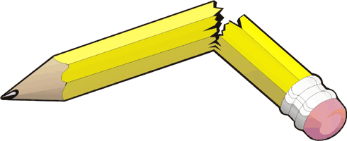](https://www.google.com/url?sa=i&rct=j&q=&esrc=s&source=images&cd=&cad=rja&uact=8&ved=0ahUKEwj9wZPOvoXPAhUJSiYKHe2jDCcQjRwIBw&url=https://clipartion.com/free-clipart-21619/&bvm=bv.132479545,d.cWw&psig=AFQjCNEVUAi5yFNOJajhduP0GbuJ9p72hQ&ust=1473620581578169)[](http://www.google.com/url?sa=i&rct=j&q=&esrc=s&source=images&cd=&cad=rja&uact=8&ved=0ahUKEwj706LYvoXPAhUGeSYKHUsRCwsQjRwIBw&url=http://www.clipartkid.com/not-sharp-pencil-cliparts/&bvm=bv.132479545,d.cWw&psig=AFQjCNGkX0J5W_-yfLn93uRpAi8hfnDx7A&ust=1473620604766989)[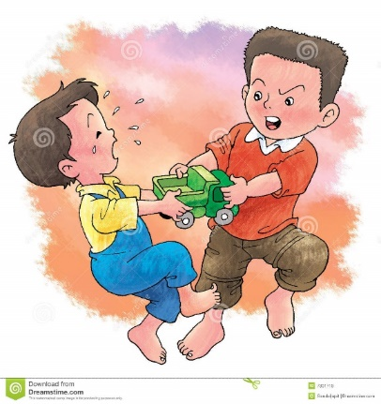](https://www.google.com/url?sa=i&rct=j&q=&esrc=s&source=images&cd=&cad=rja&uact=8&ved=0ahUKEwj25uK8v4XPAhXFRiYKHX2XCAkQjRwIBw&url=https://www.dreamstime.com/stock-photo-fight-over-toy-image7301710&bvm=bv.132479545,d.cWw&psig=AFQjCNEFr5JiU8eNPGGyDiiQ1jHryEaQZg&ust=1473620814257359)[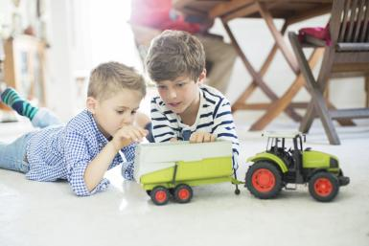](http://www.google.com/url?sa=i&rct=j&q=&esrc=s&source=images&cd=&cad=rja&uact=8&ved=0ahUKEwia0NXYv4XPAhVB7iYKHXrqDEcQjRwIBw&url=http://stayathomemoms.about.com/od/raisingyourchildren/a/Get-Children-To-Share.htm&bvm=bv.132479545,d.cWw&psig=AFQjCNHxN0fFIaOpqqClTzItyp1epKTUzw&ust=1473620868922960)

[](https://www.google.com/url?sa=i&rct=j&q=&esrc=s&source=images&cd=&cad=rja&uact=8&ved=0ahUKEwi35fX9v4XPAhUI4SYKHRh6B-AQjRwIBw&url=https://www.speechbuddy.com/blog/speech-disorders/language-sequencing-problems/&bvm=bv.132479545,d.cWw&psig=AFQjCNF349Jwis-mXNnB8f8bXhhpMvRKeg&ust=1473620947635393)[](http://www.google.com/url?sa=i&rct=j&q=&esrc=s&source=images&cd=&cad=rja&uact=8&ved=0ahUKEwjh_u2YwIXPAhWEJiYKHdeoAAoQjRwIBw&url=http://www.nscsd.org/webpages/jenkondrk/ourclassroom.cfm?subpage%3D42423&bvm=bv.132479545,d.cWw&psig=AFQjCNENG_fVSr2SDxGec_JvabRHMzmJpA&ust=1473621004270403)

[](http://www.google.com/url?sa=i&rct=j&q=&esrc=s&source=images&cd=&cad=rja&uact=8&ved=0ahUKEwjC84S5-IXPAhXIRSYKHbKSDoEQjRwIBw&url=http%3A%2F%2Fwww.satyayoga.com.sg%2Fyoga%2Fthe-boy-who-cried-wolf%2F&bvm=bv.132479545,d.cWw&psig=AFQjCNGrKuOhhAHwFqzxYWF2pRJ4S8MGug&ust=1473636083372370) [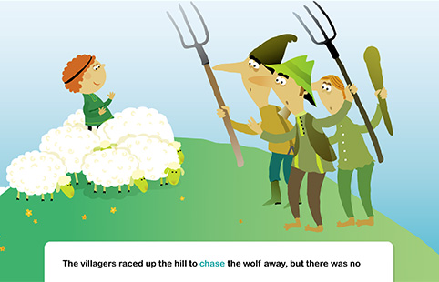](http://www.google.com/url?sa=i&rct=j&q=&esrc=s&source=images&cd=&cad=rja&uact=8&ved=0ahUKEwjC84S5-IXPAhXIRSYKHbKSDoEQjRwIBw&url=http%3A%2F%2Fwww.speakaboos.com%2Fstory%2Fthe-boy-who-cried-wolf&bvm=bv.132479545,d.cWw&psig=AFQjCNGrKuOhhAHwFqzxYWF2pRJ4S8MGug&ust=1473636083372370)