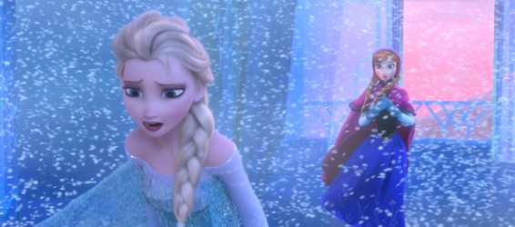

**Elsa’s reaction to her challenge is:**

**Says: “Let it go!”**

**Does: Leaves home and makes a castle to live in alone.**

**Thinks: I’m not safe and I can’t control my power.**

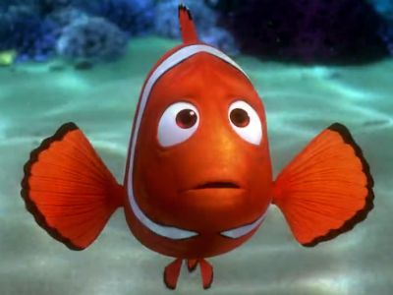

**Marlin’s reaction to his challenge is:**

**Says: “I have to find my son.”**

**Does: Goes to find his son.**

**Thinks: I can’t find him.**

**A reaction or response is what a character does, says, or thinks about the challenge.**

**Reaction or Response**

**Dogs are animals.**