[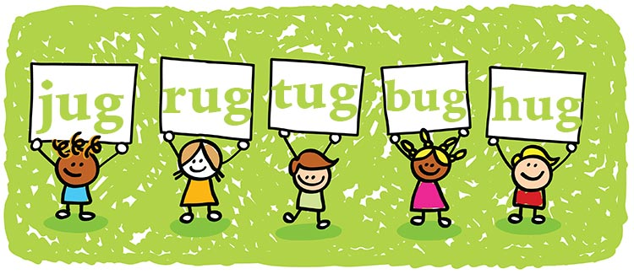](http://www.google.com/url?sa=i&rct=j&q=&esrc=s&source=images&cd=&cad=rja&uact=8&ved=0ahUKEwjNvaCf-JnQAhXM7IMKHXLOBRkQjRwIBw&url=http://www.greatschools.org/gk/articles/preschool-rhyming-words-worksheets/&psig=AFQjCNGvWPlj4ld5Pzkz1iR4aVsF35L82A&ust=1478721286054301)

**Rhyming words are words that have the same ending sound. These words help stories and poems flow.**

[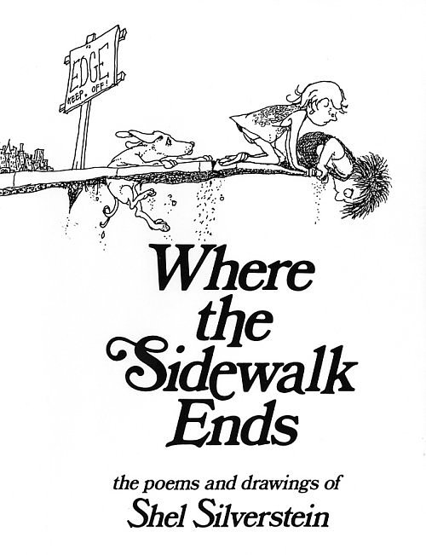](http://www.google.com/url?sa=i&rct=j&q=&esrc=s&source=images&cd=&cad=rja&uact=8&ved=0ahUKEwid4u36-JnQAhUJ2SYKHbJtByoQjRwIBw&url=http://www.redapplereading.com/blog/2015/04/poetry-books-for-children/&bvm=bv.138169073,d.amc&psig=AFQjCNE8BVz8aiDLMyiIQMucUWPI5qQZJQ&ust=1478721465945849)

[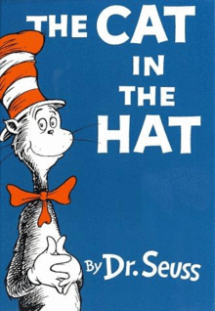](https://www.google.com/url?sa=i&rct=j&q=&esrc=s&source=images&cd=&cad=rja&uact=8&ved=0ahUKEwiC25rF-JnQAhWIOCYKHdk-AYEQjRwIBw&url=https://en.wikipedia.org/wiki/The_Cat_in_the_Hat&bvm=bv.138169073,d.amc&psig=AFQjCNHtNpQIKeD3eerFL4tl5wasVFfsJQ&ust=1478721372389002)

**Rhyming Words**