Name: _____________________________ Date: _____________
RI 2.3 Quiz
Directions: Label the cause and effect.
Word Bank
Cause Effect
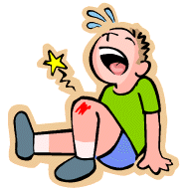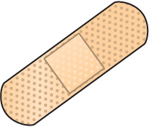
- ____________________ 2. ________________________

Name: _____________________________ Date: _____________
RI 2.3 Quiz
Directions: Label the cause and effect.
Word Bank
Cause Effect
- ____________________ 2. ________________________
Directions: Label the fact and opinion.
Word Bank
Fact Opinion

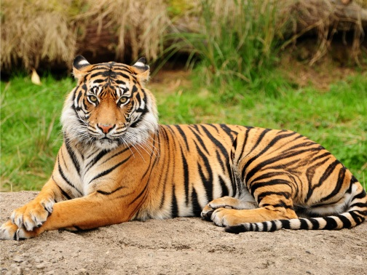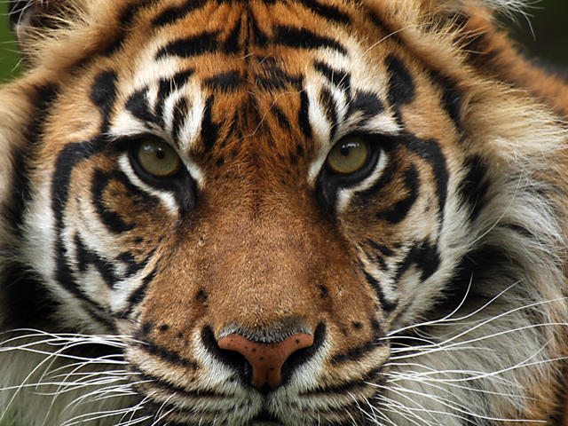
Tigers are the best animals. Tigers have two eyes.
- ____________________ 2. ________________________

Directions: Label the fact and opinion.
Word Bank
Fact Opinion

Tigers are the best animals. Tigers have two eyes.
- ____________________ 2. ________________________
Directions: Label the problem and solution.
Word Bank
Problem Solution

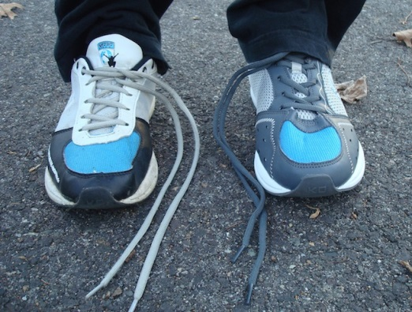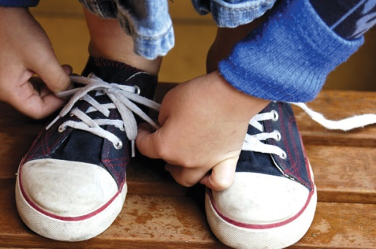
My shoes are untied. I tie my shoelaces.
- ______________________ 2. ________________________

Directions: Label the problem and solution.
Word Bank
Problem Solution

My shoes are untied. I tie my shoelaces.
- ________________________ 2. ________________________
Directions: Put the sequence in order.
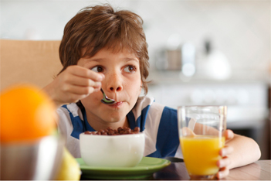
Boy eats breakfast. ___________
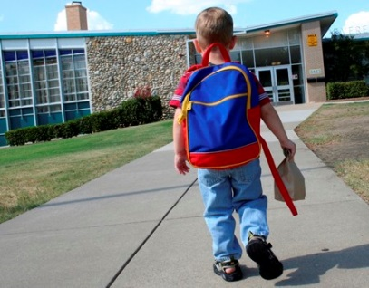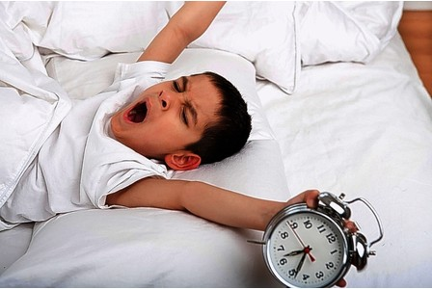
Boy goes to school. __________ Boy wakes up. _____________

Directions: Put the sequence in order.
Boy eats breakfast. _________
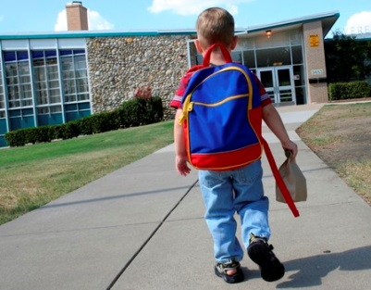
Boy goes to school. ________ Boy wakes up. ___________

