Name: ______________________________
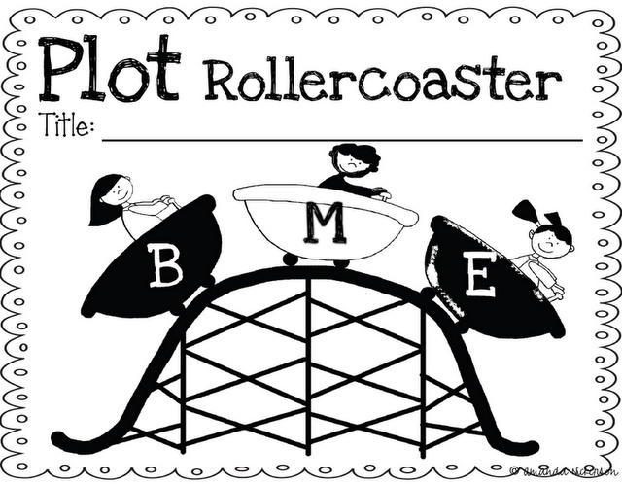
Roller Coaster Story Map
Character

The monkey likes to go
___________________________.
Title

_______________________
Middle
End
Beginning

