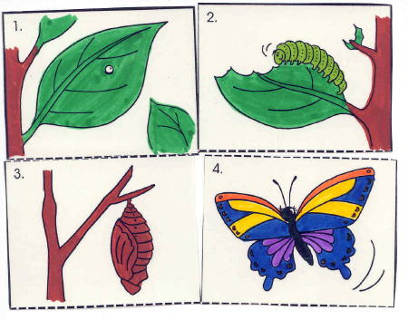

**Sequencing**

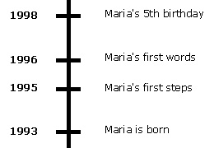

**Chronological Order**

**Sequencing is when you put events in order by steps. Chronological order is when events are put in order by time and you understand how they are related.**

**Sequencing and chronological order**