Text Feature Name | Picture of Text Feature | Definition of the Text Feature
____________________ |  | This text feature tells you the name of the book.
___________________ |  | This text feature shows you a place.
___________________ |  | This text feature shows you what something looks like.
___________________ |  | This text feature tells you about a section or chapter of the text.
____________________ |  | This text feature shows you the parts of something. It has labels.

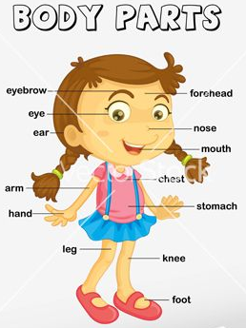 | 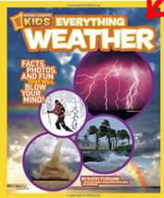 | 