Text Feature | Purpose | Image
Title | The purpose is to tell me the name of the text.
Photograph | The purpose is to show me what the text is about. | 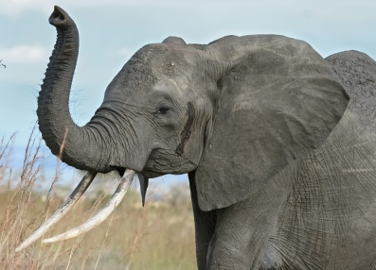
Caption | The purpose is to tell me about the photograph or illustration. | 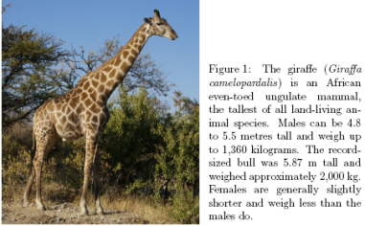
Heading | The purpose is to tell me what the entire page or chapter is about.
Subheading | The purpose is to tell me what part of the page is about. | 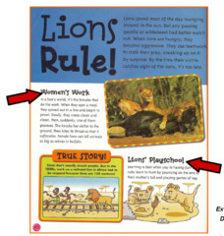
Diagram | The purpose is to show me what the text is explaining. | 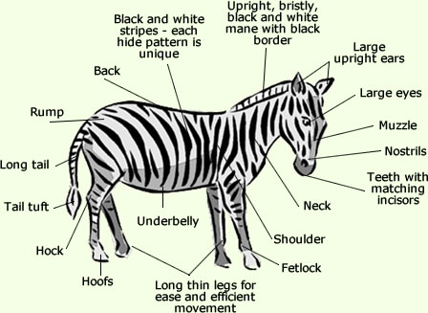
Table of Contents | The purpose is to show me what page different parts of the text are on. | 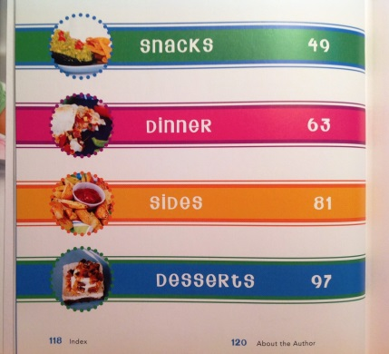
Glossary | The purpose is to tell me what different words in the text mean.
Index | The purpose is to show me what page different parts of the book are on.
Bold Words | The purpose is to help me find important words.

