[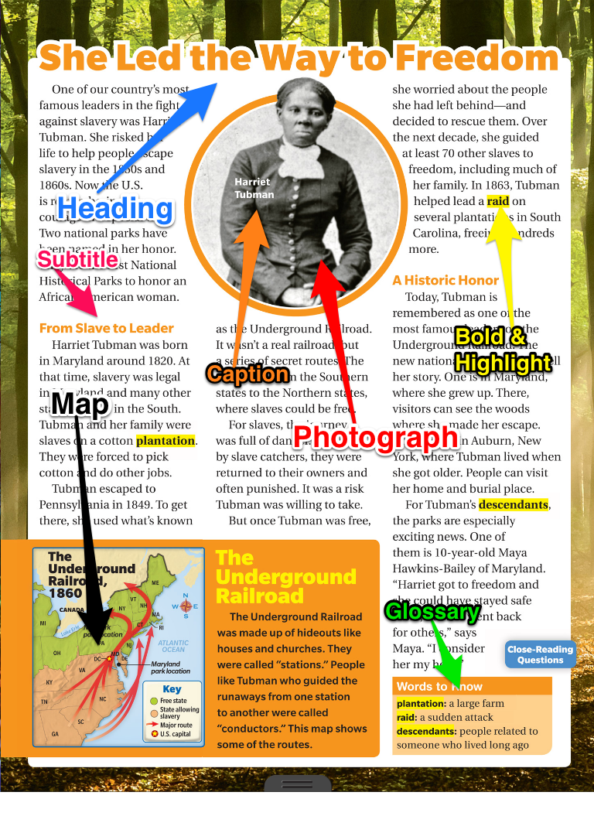](https://www.google.com/url?sa=i&rct=j&q=&esrc=s&source=images&cd=&cad=rja&uact=8&ved=0ahUKEwi6s4Wj-5fPAhUE7SYKHbuBAuMQjRwIBw&url=https%3A%2F%2Fmsjordanreads.com%2Ftag%2Fnon-fiction-text-features%2F&psig=AFQjCNEyI-oKyWRf12QUCw9Hoqzf_rJ-Qg&ust=1474255127148997)

[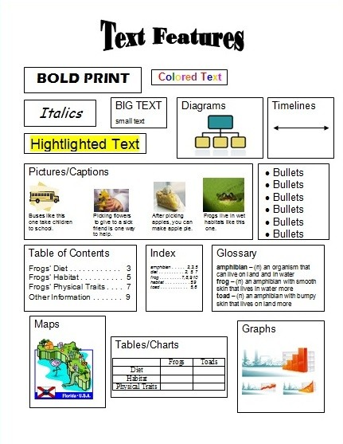](http://www.google.com/url?sa=i&rct=j&q=&esrc=s&source=images&cd=&cad=rja&uact=8&ved=0ahUKEwiPo8fZ-pfPAhVBySYKHf8pCq8QjRwIBw&url=http%3A%2F%2Fmrswarnerarlington.weebly.com%2Ftext-feature-resources.html&psig=AFQjCNEyI-oKyWRf12QUCw9Hoqzf_rJ-Qg&ust=1474255127148997)

**The text features are used to help a reader understand nonfiction texts.**

**Text features**