Name: ____________________________ Date: ___________________

**Text Features Quiz - RI 2.1 and 2.2**

Word Bank

Caption Heading Photograph Diagram

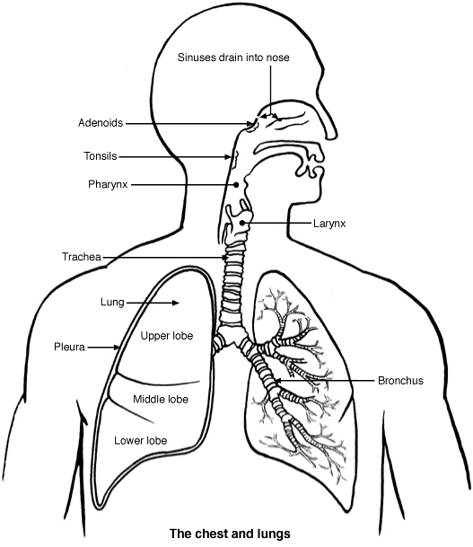

3. _____________________________

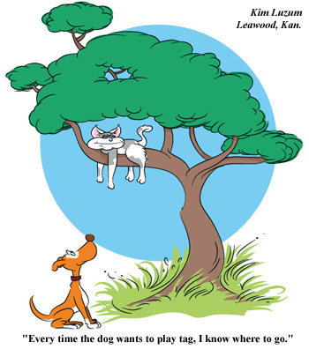

4. _________________________________________

2. _____________________

1. _______________________

