**Thick questions**

**To answer thick questions you have to think about the text and use information from it. Thick questions can have more than one answer.**

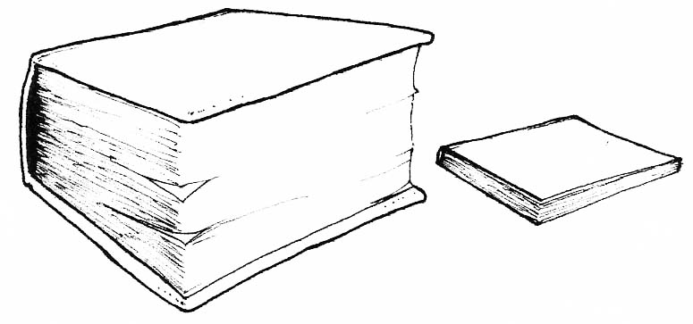

Question Words:

* how
* why