**Thin questions**

**Thin questions have simple answers that you can find in the text. These questions have only one answer.**

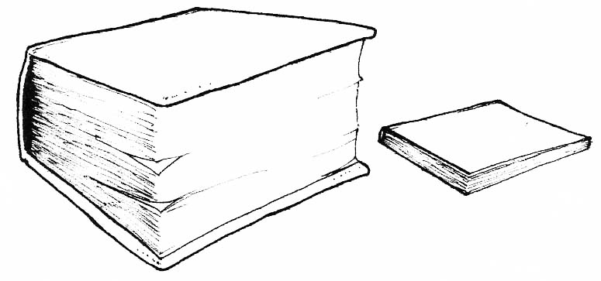

Question Words:

* who
* what
* where
* when
* how